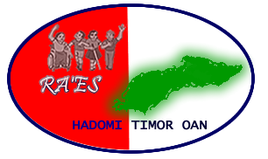
Case Study:

People with Disabilities earning an independent livelihood through coffee production in Ermera

**Tetun iha kraik

Timor-Leste, and particularly the mountainous Ermera municipality, is well known for its coffee production. But coffee consumers don't always stop to think about the people who grew the beans in their morning drink. But now in Ermera, Ra'es Hadomi Timor Oan, the national disabled person's organisation in Timor-Leste, is helping people with disabilities turn their plans to produce coffee into reality. So, your next cup could have been produced by people with disabilities!
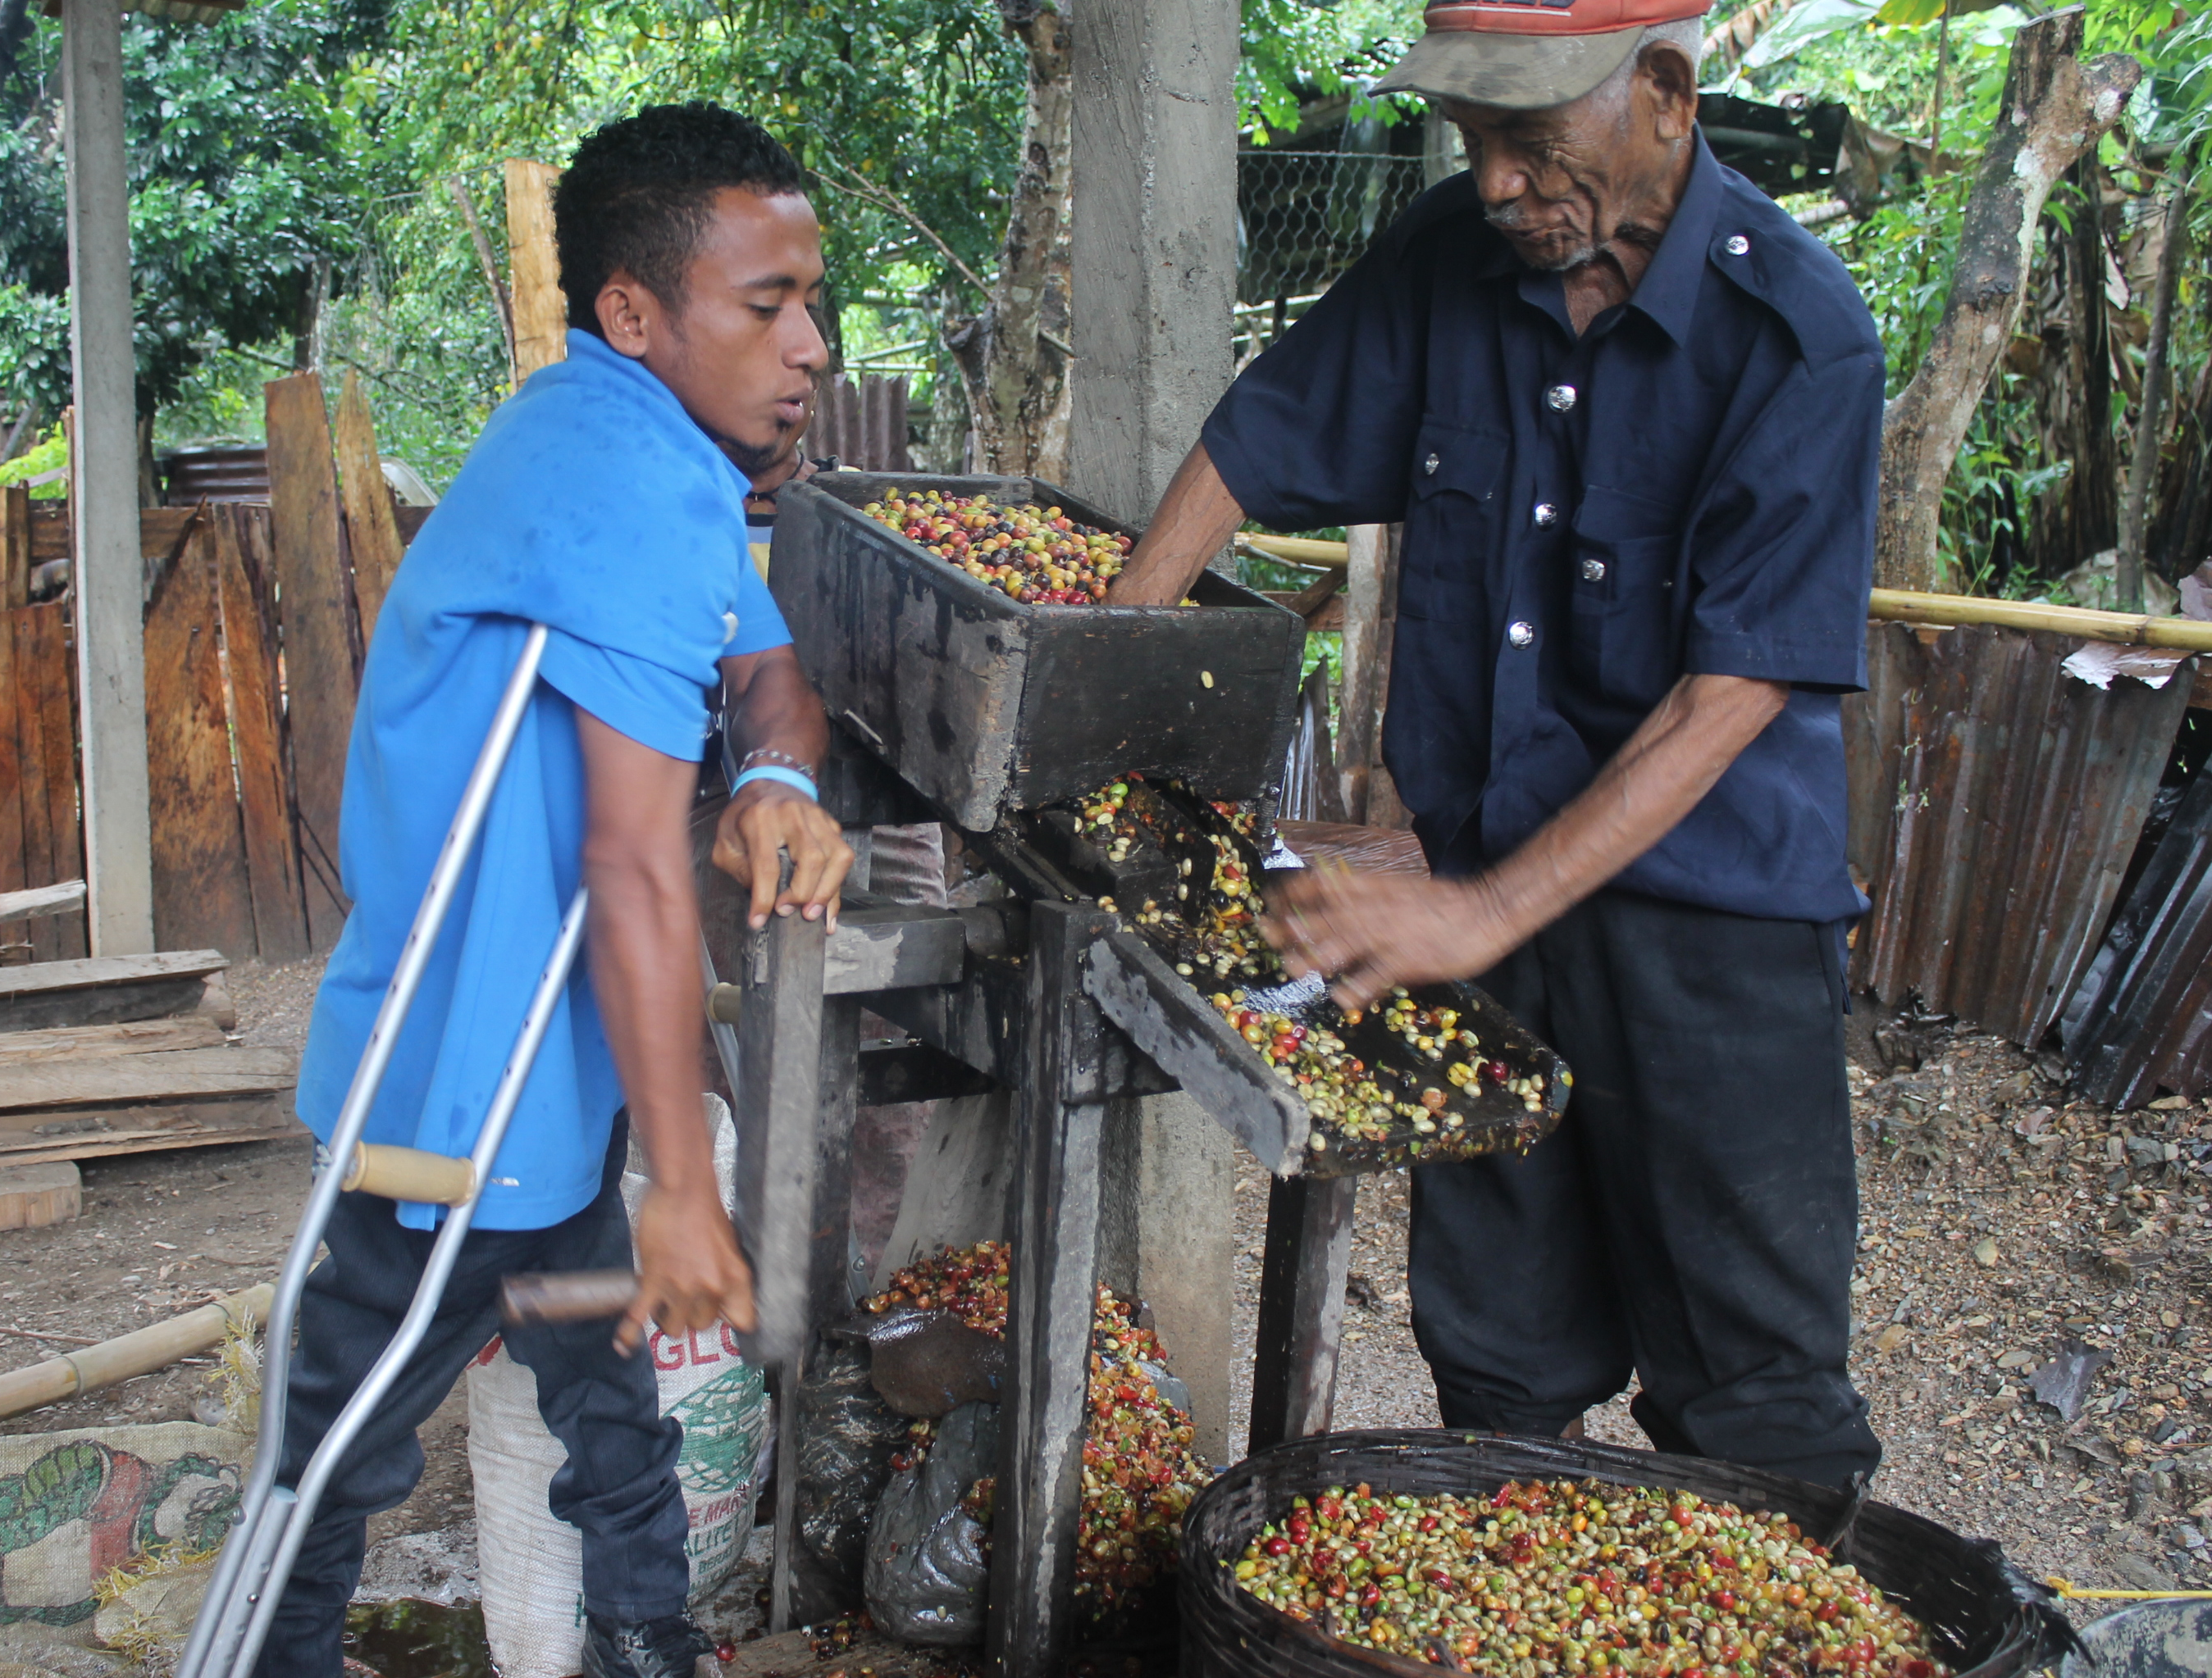
Photo: RHTO's Ermera field officer helps a self-help group member process coffee beans.
Credit: RHTO.

Through our National Disability Awareness Project (supported by The Leprosy Mission and the Australian Government), RHTO is supporting a number of self-help groups made up of people with disabilities and their families. We work together with groups to develop their structures and regulations, and identify feasible business plans. RHTO also provides a $500 microcredit loan that the groups can pack back slowly. We started providing these loans after we realised that people with disabilities weren't easily able to access microfinance and credit through other mainstream (non disability-specific) NGOs.

RHTO's support for self-help groups was also boosted in 2015, when we were provided with a small grant from the Australian Volunteers International Community Grants Scheme. Part of this funding included support to undertake a baseline capacity assessment of our self-help groups across the country, in order to determine training requirements. We used this information to design a specific training program which covered topics like group governance, decision-making, advocacy, business and financial management. Sixty-five participants from our self-help groups participated in the training, including representatives of two self-help groups in Ermera.
After the training, during a follow-up visit from RHTO staff to see how groups have been implementing their new skills, Ermera group members said that they have been making changes to their financial management approach, to make sure they are tracking expenditure, income and profit on a regular basis.

Both of our groups in Ermera have plans to grow and expand their coffee businesses. One of our groups in Ermera has been able to use the income they receive through their coffee production to start a new side-business designing and producing beautiful flowerpots and vases to sell in their village. The group has started to transport their vases to markets in nearby towns, and also to Dili.

Another group we support in Ermera, called "Grupu Matadalan Ba Jerasaun Defisiénsia", made up of young people with disabilities and their families, used their initial microcredit loan to start a baking business. After repaying the loan, they started loaning out small amounts of money to people in their town, accruing interest on those loans. This group is now also expanding into coffee. They have a small amount of land where they grow coffee, and now they hope to begin processing and packaging the coffee themselves.

By diversifying their livelihoods activities, people with disabilities in Ermera are making themselves more resilient, and are demonstrating to their communities that people with disabilities can be productive and contributing members of society.

To find out more about the activities of RHTO and the self-help groups we support, contact our office on +670 331 0540.

...............................................

Istoria Badak:

Ema ho Defisiénsia ho fila liman rasik liu husi produsaun kafé iha Ermera

Timor-Leste, liu-liu Munisipiu Ermera ne'ebé iha foho barak, famozu tanba produs kafé. Maibe, bainhira ema hemu kafé, sira laduun para no hanoin kona-ba ema se kuda kafé iha sira nia bebidas. Maibe agora iha Ermera, Ra'es Hadomi Timor Oan, hanesan organizasaun nasionál ba ema ho defisiénsia iha Timor-Leste, ajuda ema ho defisiénsia troka sira nia planu produs kafé tó realidade. Ne'e duni, dala hafoin ita boot hemu kafé, karik ema ho defisiénsia mak produs kafé ne'e!

Liu hosi ami-nia Projeitu Nasionál Hasa'e Konsensia Defisiénsia (ne'ebé simu suporta hosi Misaun Lepra no Governu Australia), RHTO suporta grupu tulun-an rasik ruma. Grupu hirak ne'e mak involve ema ho defisiénsia no sira nia familia. Ami servisu hamatuk grupu sira atu dezenvolve sira nia estrutura no regulamtnu, no identifika planu negosiu ne'ebé diak ba sira. RHTO mós fo empresta osan microkreditu, montante $500, ne'ebé sira bele selu fali ba ami ne-neik. RHTO hahu provida osan empresta ne'e, tanba ami realiza katak ema ho defisiénsia laduun bele asesu mikro-finansas no kreditu liu hosi ONG seluk ne'ebé la servisu spesifiku ho ema ho deifiénsia.

RHTO-nia suporta ba ami-nia grupu tulun-an rasik aumenta iha tinan 2015, bainhira ami simu osan ki'ik hosi Australian Volunteers International nia Community Grants Scheme. Parte fundus ne'e inklui suporta ba hala'o asesmentu linea bazia (baseline) kona-ba grupu sira nia kapasidade no saida mak treinamentu sira presiza. Ami uza informasaun hodi dezeñu programa treinamentu mak spesifiku ne'ebé inklui topiku hanesan governasaun iha grupu laran, advokasia, jere negosiu no orsamentu. Partisipante nain 65 partisipa iha treinamentu iha Dezembru 2015, inklui representante hosi grupu tulun-an rasik nain rua iha Ermera.

Depois de treinamentu, funsionáriu RHTO halo vizita ida-ne'ebé tutan (follow-up) atu haree oinsá mak grupu sira iha ona implementa sira-nia abilidade foun. Membru grupu iha Ermera hatete katak sira iha tiha ona atu halo mudansa ba sira-nia abordajen jestaun finanseira, atu asegura katak sira mak kona ba despeza, rendimentu no lukru iha baze regulár.

Ami-nia grupu hotu iha Emera iha planu atu aumenta sira-nia negosiu kafé. Grupu ida iha Ermera uza rendementu sira simu hosi produsaun kafé no hahu negosiu foun hanesan dezeñu no produs vazu ba ai-funan. Sira faan vazu iha sira nia suku, nomós hahu transporte vazu ba suku seluk no tuun ba Dili hodi faan.

Grupu ida seluk mak RHTO suporta iha Emera, naran " Grupu Matadalan Ba Jerasaun Defisiénsia", uza sira nia osan mikrokreditu hodi hahu negosiu hanesan faan dosi. Despois sira selu fali osan, sira hahu fo empresta osan ki'ik ba ema seluk iha sira nia komunidade, no simu osan-funan hosi prosesu ne'e. Agora, grupu ida ne'e, ne'ebé inklui foin sae ho defisiénsia no sira nia familia, hahu produs kafé. Sira iha rai ruma ne'ebé sira kuda kafé. Agora sira espera bele prosesu no falun kafé ho sira-nia-an.

Liu hosi atividade fila liman oi-oin, ema ho defisiénsia iha Ermera hasa'e sira-nia reziliente (buka-hiras), nomós hatudu ba sira-nia komunidade katak ema ho defisiénsia mós membru sosiedade mak produktivu no kontribui.

Ita bo'ot bele kontaktu RHTO nia kantor (+670 331 0540) hodi hetan informasaun klean liu kona-ba RHTO nia servisu no ami nia grupu tulan-an rasik.

