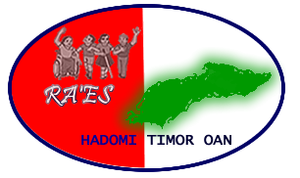
Case Study:

People with disabilities helping to build the capacity of all community members in Manufahi

**Tetun iha kraik

People with disabilities in Timor face particular barriers and struggle to enter employment. But now in Manufahi, Ra'es Hadomi Timor Oan, the national disabled person's organisation in Timor-Leste, is helping people with disabilities demonstrate that they can contribute to their communities. One self-help group's plan to teach computer skills to community members is being supported to become reality. "Ema ho defisiénsia mós bele" ("People with disabilities also can!")

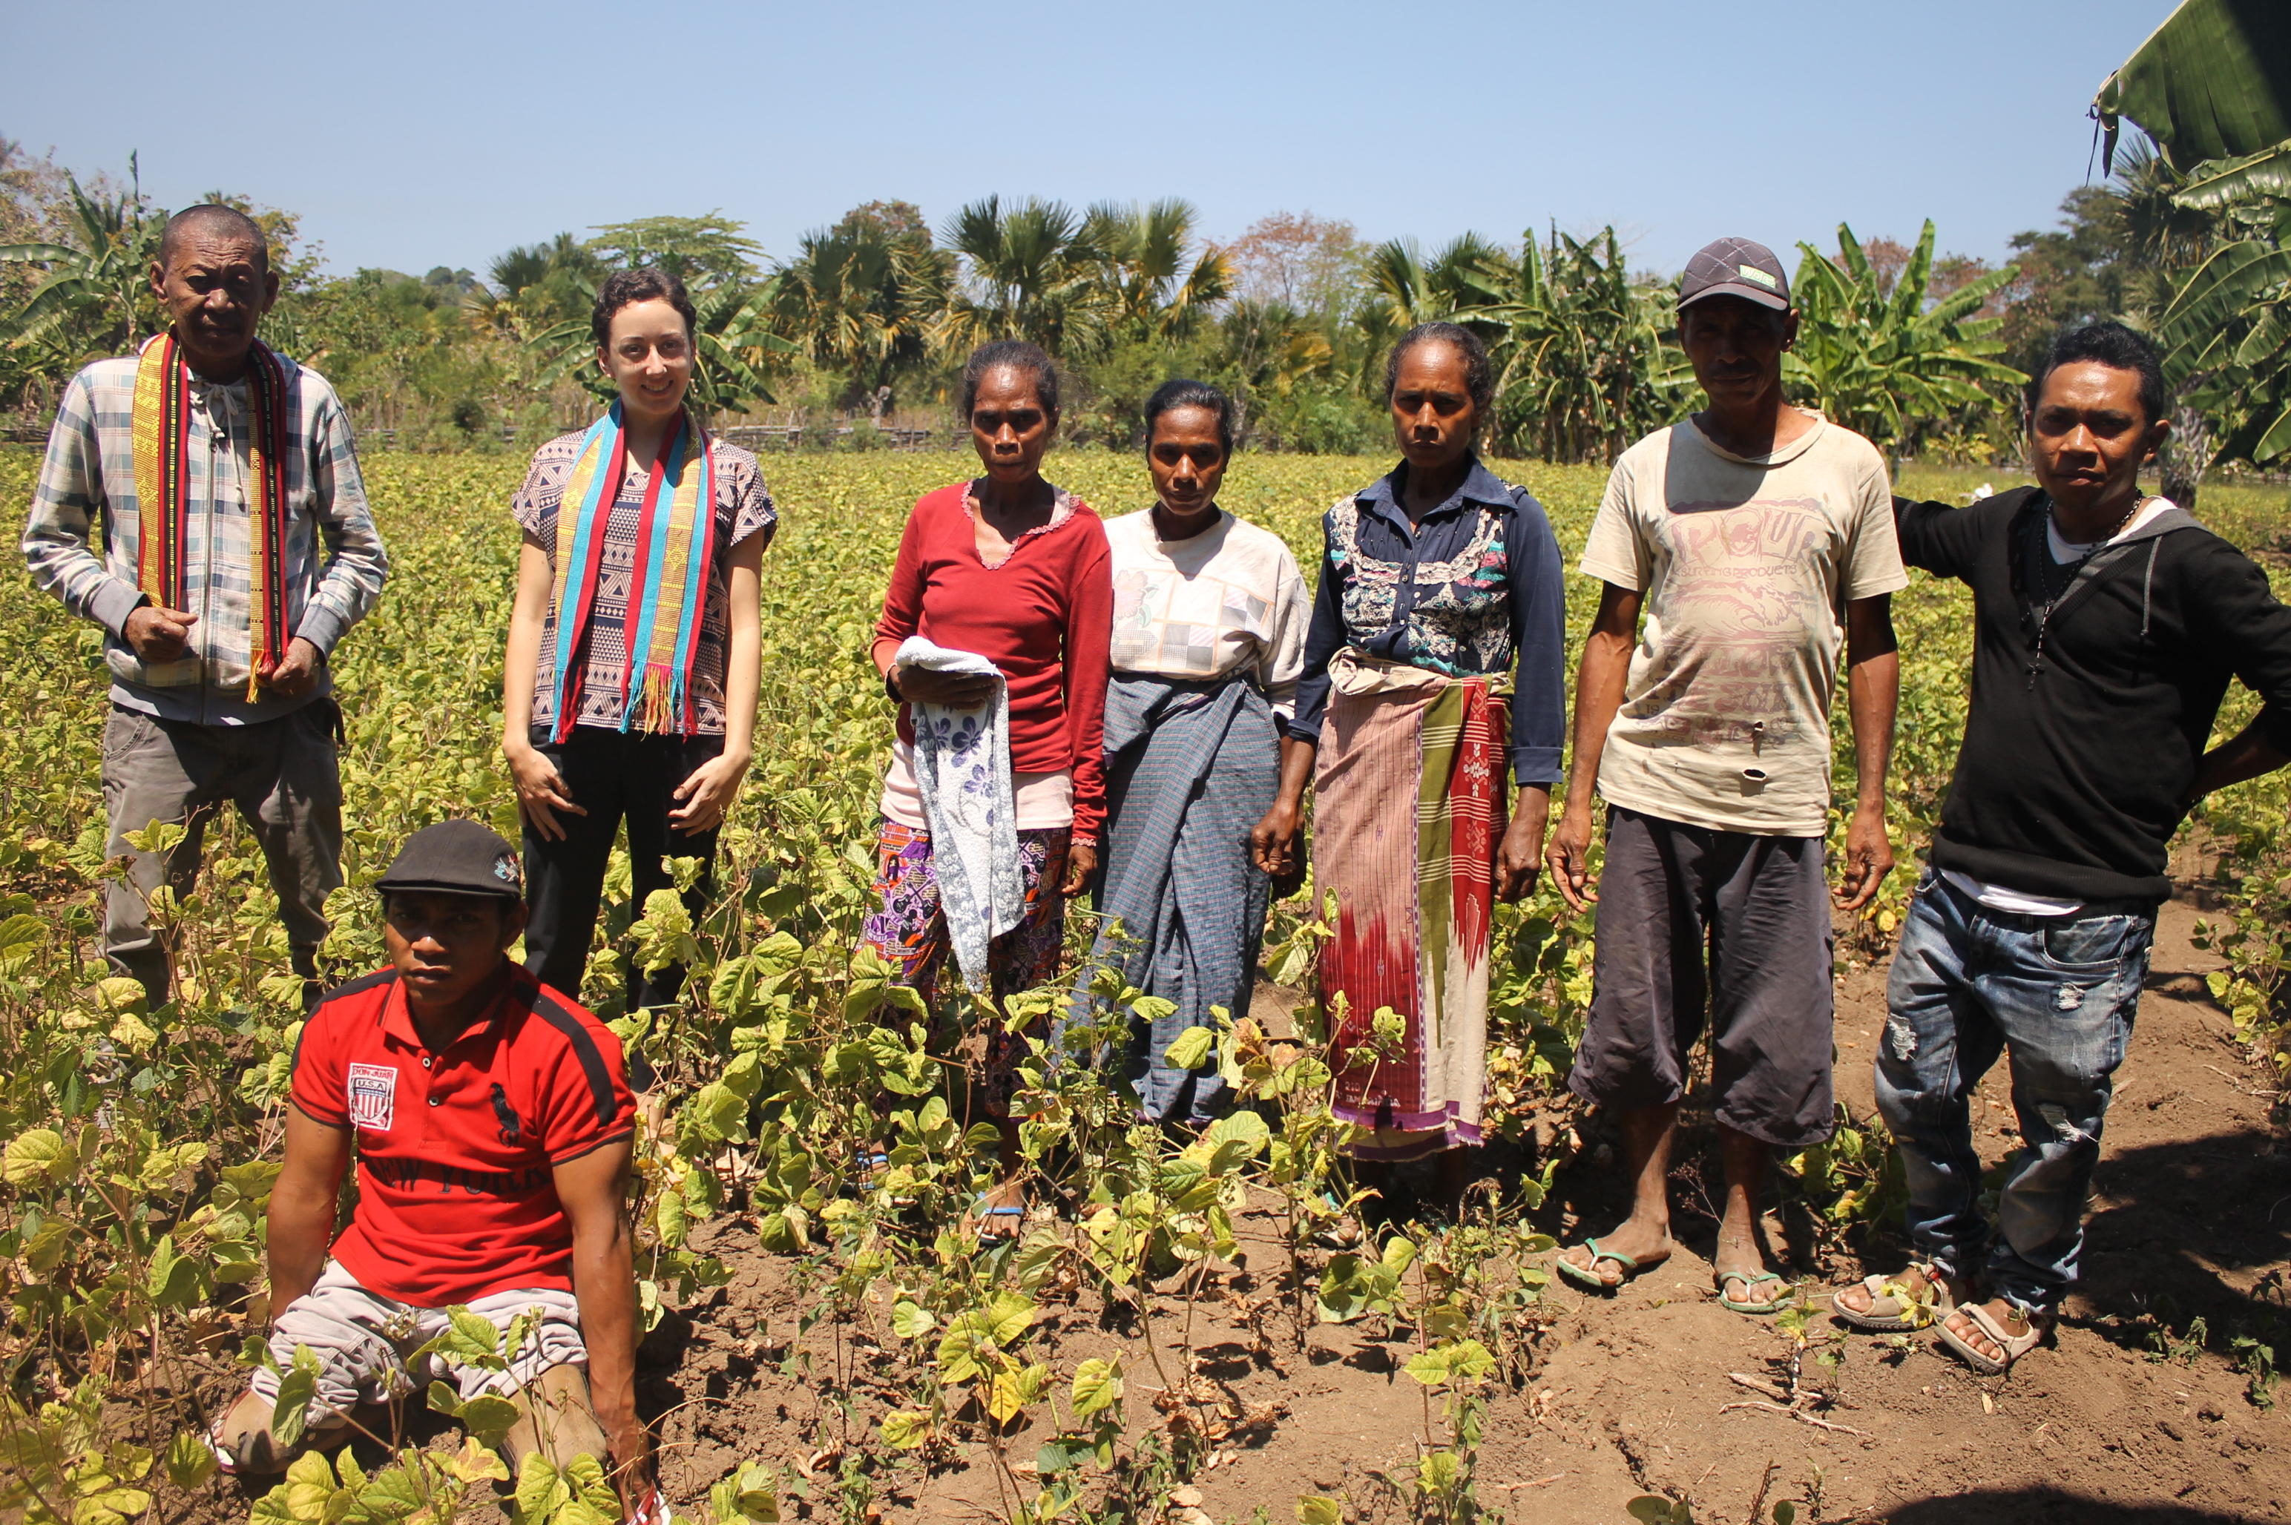
Photo: RHTO staff members and Grupu Centro Treinamentu Defisiensia Manufahi self-help group members and family stand in the group's farm field. Credit: RHTO.

In Timor-Leste discrimination and stigma against people with disabilities remains common. People with disabilities face barriers in accessing education and vocational training, which in turn hinders their ability to enter into employment. Indeed, of 49 women with disabilities recently interviewed by RHTO, 86 per cent said they had never accessed vocational training, and 65 per cent do not work or engage in livelihood activities.

As the national Disabled Person’s Organisation in Timor-Leste, RHTO is working to remove these barriers and support people with disabilities get access to vocational training and employment. Through our National Disability Awareness Project (supported by The Leprosy Mission and the Australian Government), RHTO has encouraged people with disabilities to come together and form self-help groups. We support the groups to develop their structures and regulations, identify feasible business plans, and we provide a $500 microcredit loan to help start or expand the groups' businesses. These self-help groups are often the only support through which people with disbailities can earn a living. A survey of 300 people with disabilities undertaken by ADTL (Asosiasaun Defisiénsia Timor-Leste) in 2014 showed that 47 per cent were self-employed though self-help groups established by organisations working in the disability sector.

These self-help groups also represent one of the most powerful ways to change attitudes and beliefs about disability, because they show people without disability that people with disability are capable of learning, having a livelihood, and contributing to their families and communities. For example, one of RHTO's self-help groups in Manufahi are working hard to prove that people with disabilities can contribute.

The "Grupu Centro Treinamentu Defisiensia Manufahi" group was established by a group of people with disabilities who wanted their group activities to benefit their whole community, not just themselves. They had the idea to train a few group members in important computer skills, which they could then use to train other people, both with and without disabilities, in their Suco (village). To help them achieve this goal, RHTO has facilitated access to vocational training. Three group members have been supported to study a six-month computer skills course at the Ahisaun Disability Foundation training centre in Dili.

RHTO's support for the group was also boosted in 2015, when we were provided with a small grant from the Australian Volunteers International Community Grants Scheme. Part of this funding included support to design a specific training program which covered topics like group governance, decision-making, advocacy, business and financial management. Sixty-five participants from our self-help groups participated in the training, including representatives of the Manufahi group.
After the training, RHTO staff undertook a follow-up visit to see how the self help groups have been implementing their new skills. During these visits, people with disabilities in Manufahi said that the training had taught them new skills about financial management, and how to track their expenditure, income, and profits through book-keeping processes. The group members are now preparing to return to Manufahi, to teach their new computer skills to other community members.

To find out more about the activities of RHTO and the self-help groups we support, contact our office on +670 331 0540.

...............................................

Istoria Badak:

Ema ho Defisiénsia fo ajuda no hasa'e kapasidade ba ema hotu iha komunidade iha Manufahi

Ema ho defisiénsia iha Timor hasoru obstákulu sira ne'ebé partikulár, no luta atu tama ba empregu. Maibé, agora iha Manufahi, Ra'es Hadomi Timor Oan, mak hanesan organizasaun nasionál ba ema ho defisiénsia iha Timor-Leste, mak atu ajuda ema ho defisiénsia hatudu katak sira bele kontribui ba sira-nia komunidade. RHTO suporta atu sai realidade grupu tulun-an rasik ida-nia planu atu hanorin computer abilidade ba membru komunidade. "Ema ho defisiénsia mós bele!"

Iha Timor-Leste diskriminasaun no stigma hasoru ema ho defisiénsia sira kontinua sai halo baibain. Ema ho defisiénsia sira hasoru difikuldade iha asesu ba edukasaun no formasaun profisionál. Ne'e duni, sira mos iha problema atu tama ba empregu. Tuir loloos, hosi feto ho defisiénsia sira nain 49, ne'ebé RHTO foin lalais ne'e entrevista, porsentu 86 dehan katak sira la asesu ba formasaun profisionál, no porsentu 65 la serbisu no la envolve iha atividade fila liman.

Iha nu'udar organizasaun nasionál ba ema ho defisiénte nian iha Timor-Leste, RHTO servisu atu hasai barreira hirak ne'e, no apoiu ema ho defisiénsia hetan asesu ba formasaun profisionál no empregu. Liu husi ami-nia Projeitu Nasionál Hasa'e Konsensia Defisiénsia (ho suporta husi Misaun Lepra no Governu Austrália), RHTO ona enkoraja ema ho defisiénsia atu halibur hamutuk no forma grupu tulun an rasik. Ita apoia grupu atu dezenvolve sira-nia estrutura no regulamentu, identifika planu negósiu ne'ebé adota, no ami fó osan empresta montante $500 atu hahú ka habelar grupu nia negósiu. Grupu tulun an rasik sira-neʼe mak dala barak simu apoiu de'it liu hosi ema ho disbailities bele manan moris. Levantamentu kona-ba ema ho defisiénsia nain 300 ne'ebé hala'o hosi ADTL (Asosiasaun Defisiénsia Timor-Leste) iha tinan 2014 ne'ebé hatudu katak porsentu 47 mak auto-empregu liu hosi grupu tulun an rasik ne'ebé estabelese hosi organizasaun sira ne'ebé servisu iha setór defisiénsia.

Grupu tulun an rasik mós reprezenta dalan ne'ebé forte liu atu muda ema seluk nia atitude no fiar kona-ba defisiénsia, tanba Grupu sira hatudu katak ema ho defisiénsia iha kapasidade atu aprende, iha kapasidade atu serbisu no hala'o fila liman rasik, no bele kontribui ba sira-nia família no komunidade. Puezemplu, grupu tulun an rasik ida ne'ebé RHTO ajuda iha Manufahi serbisu makaʼas atu prova katak ema ho defisiénsia bele kontribui.

"Grupu Centro Treinamentu Defisiensia Manufahi" harii hosi ema ho defisiénsia ruma sira ne'ebé hakarak sira-nia grupu no atividade sira fo benefísiu ba sira-nia komunidade tomak, laos ba sira deit. Sira iha hanoin atu fó treinamentu ba membru grupu balu iha abilidade computer ne'ebé importante, ne'ebé sira bele uza atu fo treinamentu ba ema seluk, inklui ema ho no la ho defisiénsia, iha sira-nia Suku. Atu ajuda sira atu atinji objetivu ida ne'e, RHTO fasilita asesu ba formasaun profisionál. Membru grupu tolu hetan tiha ona apoiu ba estuda iha fulan neen computer abilidade kursu iha sentru formasaun Ahisaun Fundasaun ba Defisiénsia iha Dili nia laran.

RHTO nia suporta ba ami-nia grupu tulun-an rasik aumenta iha tinan 2015, bainhira ami simu osan ki'ik hosi Australian Volunteers International nia Community Grants Scheme. Parte fundus ne'e inklui suporta ba hala'o asesmentu linea bazia (baseline) kona-ba grupu sira nia kapasidade no saida mak treinamentu sira presiza. Ami uza informasaun hodi dezeñu programa treinamentu mak spesifiku ne'ebé inklui topiku hanesan governasaun iha grupu laran, advokasia, jere negosiu no orsamentu. Partisipante nain 65 partisipa iha treinamentu iha Dezembru 2015, inklui representante hosi grupu tulun-an rasik nain iha Manufahi.

Depois de treinamentu, funsionáriu RHTO halo vizita ida-ne'ebé tutan (follow-up) atu haree oinsá mak grupu sira iha ona implementa sira-nia abilidade foun. Liu hosi vizita ne'e, ema ho defisiénsia iha Manufahi hatete katak treinamentu iha Dezembru hanorin ba sira skil foun kona-ba jere osan, no oinsa mak cek sira-nia rendementu, gastus, no lukru liu hosi prosesu book-keeping. Membru grupu agora prepara atu fila fali ba Manufahi, atu hanorin sira-nia abilidade foun kona-ba komputadór ba membru komunidade sira seluk.

Ita bo'ot bele kontaktu RHTO nia kantor (+670 331 0540) hodi hetan informasaun klean liu kona-ba RHTO nia servisu no ami nia grupu tulan-an rasik.

